Name - Gaurang A Raorane Div - D15A Roll no - 49 Batch - C

Experiment - 7

Aim - To write meta data of your Ecommerce PWA in a Web app manifest file to enable add to homescreen feature.

Theory -

It's clear that PWAs offer several advantages over traditional web apps, particularly in terms of providing a more native-like experience, ease of access, faster services, engaging features, and real-time data access.

PWAs leverage modern web technologies and principles to deliver a more app-like experience to users while maintaining the flexibility and accessibility of web apps. By incorporating features such as service workers, PWAs can offer offline capabilities, faster loading times, and seamless updates without requiring users to download or install new versions manually.

The key features of PWAs that distinguish them from regular web apps include:

1. Progressive Enhancement: PWAs are built with progressive improvement principles, ensuring that they work for every user regardless of the browser or device they are using.

2. Responsive Design: PWAs adapt to various screen sizes and orientations, providing a consistent user experience across desktops, mobile devices, and tablets.

3. App-like Experience: PWAs behave like native apps in terms of interaction and navigation, providing a smoother and more immersive user experience.

4. Automatic Updates: PWAs can receive updates automatically from the server, ensuring that users always have access to the latest features and content without needing to manually update the app.

5. Security: PWAs are served over HTTPS to ensure secure connections and prevent unauthorized access or tampering of data.

6. Search Engine Indexing: PWAs are identified as applications and can be indexed by search engines, improving discoverability and visibility.

7. Reactivatable: PWAs make it easy for users to reactivate the application and receive notifications, enhancing user engagement and retention.

Overall, PWAs represent a significant advancement in web app development, offering a compelling alternative to traditional native apps with their enhanced performance, user experience, and accessibility across various platforms and devices.

**Code -**

**Index.html**

<!DOCTYPE html>

<html lang="en">

<head>

<meta charset="UTF-8">

<meta http-equiv="X-UA-Compatible" content="IE=edge">

<meta name="viewport" content="width=device-width, initial-scale=1.0">

<meta name="theme-color" content="#4285f4">

<meta name="viewport"

content="width=device-width,

initial-scale=1">

<meta http-equiv="X-UA-Compatible"

content="ie=edge">

<title>Glowing - Reveal The Beauty of Skin</title>

<link rel="shortcut icon" href="./favicon.svg" type="image/svg+xml">

<link rel="stylesheet" href="./assets/css/style.css">

<link rel="preconnect" href="https://fonts.googleapis.com">

<link rel="preconnect" href="https://fonts.gstatic.com" crossorigin>

<link href="https://fonts.googleapis.com/css2?family=Urbanist:wght@400;500;600;700;800&display=swap" rel="stylesheet">

<link rel="preload" as="image" href="./assets/images/logo.png">

<link rel="preload" as="image" href="./assets/images/hero-banner-1.jpg">

<link rel="preload" as="image" href="./assets/images/hero-banner-2.jpg">

<link rel="preload" as="image" href="./assets/images/hero-banner-3.jpg">

<link rel="manifest" href="manifest.json">

<script src="serviceworker.js"></script>

</head>

<body id="top">

<script>

// Add event listener to execute code when page loads

window.addEventListener('load', () => {

// Call registerSW function when page loads

registerSW();

});

// Register the Service Worker

async function registerSW() {

// Check if browser supports Service Worker

if ('serviceWorker' in navigator) {

try {

// Register the Service Worker named 'serviceworker.js'

await navigator.serviceWorker.register('serviceworker.js');

}

catch (e) {

// Log error message if registration fails

console.error('ServiceWorker registration failed: ', e);

}

}

}

if ('Notification' in window) {

Notification.requestPermission().then(function (permission) {

if (permission === 'granted') {

console.log('Notification permission granted.');

} else {

console.warn('Notification permission denied.');

}

});

}

</script>

<header class="header">

<div class="alert">

<div class="container">

<p class="alert-text">Free Shipping On All U.S. Orders $50+</p>

</div>

</div>

<div class="header-top" data-header>

<div class="container">

<button class="nav-open-btn" aria-label="open menu" data-nav-toggler>

<span class="line line-1"></span>

<span class="line line-2"></span>

<span class="line line-3"></span>

</button>

<div class="input-wrapper">

<input type="search" name="search" placeholder="Search product" class="search-field">

<button class="search-submit" aria-label="search">

<ion-icon name="search-outline" aria-hidden="true"></ion-icon>

</button>

</div>

<a href="#" class="logo">

<img src="./assets/images/logo.png" width="179" height="26" alt="Glowing">

</a>

<div class="header-actions">

<button class="header-action-btn" aria-label="user">

<ion-icon name="person-outline" aria-hidden="true" aria-hidden="true"></ion-icon>

</button>

<button class="header-action-btn" aria-label="favourite item">

<ion-icon name="star-outline" aria-hidden="true" aria-hidden="true"></ion-icon>

<span class="btn-badge">0</span>

</button>

<button class="header-action-btn" aria-label="cart item">

<data class="btn-text" value="0">$0.00</data>

<ion-icon name="bag-handle-outline" aria-hidden="true" aria-hidden="true"></ion-icon>

<span class="btn-badge">0</span>

</button>

</div>

<nav class="navbar">

<ul class="navbar-list">

<li>

<a href="#home" class="navbar-link has-after">Home</a>

</li>

<li>

<a href="#collection" class="navbar-link has-after">Collection</a>

</li>

<li>

<a href="#shop" class="navbar-link has-after">Shop</a>

</li>

<li>

<a href="#offer" class="navbar-link has-after">Offer</a>

</li>

<li>

<a href="#blog" class="navbar-link has-after">Blog</a>

</li>

</ul>

</nav>

</div>

</div>

</header>

<div class="sidebar">

<div class="mobile-navbar" data-navbar>

<div class="wrapper">

<a href="#" class="logo">

<img src="./assets/images/logo.png" width="179" height="26" alt="Glowing">

</a>

<button class="nav-close-btn" aria-label="close menu" data-nav-toggler>

<ion-icon name="close-outline" aria-hidden="true"></ion-icon>

</button>

</div>

<ul class="navbar-list">

<li>

<a href="#home" class="navbar-link" data-nav-link>Home</a>

</li>

<li>

<a href="#collection" class="navbar-link" data-nav-link>Collection</a>

</li>

<li>

<a href="#shop" class="navbar-link" data-nav-link>Shop</a>

</li>

<li>

<a href="#offer" class="navbar-link" data-nav-link>Offer</a>

</li>

<li>

<a href="#blog" class="navbar-link" data-nav-link>Blog</a>

</li>

</ul>

</div>

<div class="overlay" data-nav-toggler data-overlay></div>

</div>

<main>

<article>

<section class="section hero" id="home" aria-label="hero" data-section>

<div class="container">

<ul class="has-scrollbar">

<li class="scrollbar-item">

<div class="hero-card has-bg-image" style="background-image: url('./assets/images/hero-banner-1.jpg')">

<div class="card-content">

<h1 class="h1 hero-title">

Reveal The <br>

Beauty of Skin

</h1>

<p class="hero-text">

Made using clean, non-toxic ingredients, our products are designed for everyone.

</p>

<p class="price">Starting at $7.99</p>

<a href="#" class="btn btn-primary">Shop Now</a>

</div>

</div>

</li>

<li class="scrollbar-item">

<div class="hero-card has-bg-image" style="background-image: url('./assets/images/hero-banner-2.jpg')">

<div class="card-content">

<h1 class="h1 hero-title">

Reveal The <br>

Beauty of Skin

</h1>

<p class="hero-text">

Made using clean, non-toxic ingredients, our products are designed for everyone.

</p>

<p class="price">Starting at $7.99</p>

<a href="#" class="btn btn-primary">Shop Now</a>

</div>

</div>

</li>

<li class="scrollbar-item">

<div class="hero-card has-bg-image" style="background-image: url('./assets/images/hero-banner-3.jpg')">

<div class="card-content">

<h1 class="h1 hero-title">

Reveal The <br>

Beauty of Skin

</h1>

<p class="hero-text">

Made using clean, non-toxic ingredients, our products are designed for everyone.

</p>

<p class="price">Starting at $7.99</p>

<a href="#" class="btn btn-primary">Shop Now</a>

</div>

</div>

</li>

</ul>

</div>

</section>

<!--

- #COLLECTION

-->

<section class="section collection" id="collection" aria-label="collection" data-section>

<div class="container">

<ul class="collection-list">

<li>

<div class="collection-card has-before hover:shine">

<h2 class="h2 card-title">Summer Collection</h2>

<p class="card-text">Starting at $17.99</p>

<a href="#" class="btn-link">

<span class="span">Shop Now</span>

<ion-icon name="arrow-forward" aria-hidden="true"></ion-icon>

</a>

<div class="has-bg-image" style="background-image: url('./assets/images/collection-1.jpg')"></div>

</div>

</li>

<li>

<div class="collection-card has-before hover:shine">

<h2 class="h2 card-title">What’s New?</h2>

<p class="card-text">Get the glow</p>

<a href="#" class="btn-link">

<span class="span">Discover Now</span>

<ion-icon name="arrow-forward" aria-hidden="true"></ion-icon>

</a>

<div class="has-bg-image" style="background-image: url('./assets/images/collection-2.jpg')"></div>

</div>

</li>

<li>

<div class="collection-card has-before hover:shine">

<h2 class="h2 card-title">Buy 1 Get 1</h2>

<p class="card-text">Starting at $7.99</p>

<a href="#" class="btn-link">

<span class="span">Discover Now</span>

<ion-icon name="arrow-forward" aria-hidden="true"></ion-icon>

</a>

<div class="has-bg-image" style="background-image: url('./assets/images/collection-3.jpg')"></div>

</div>

</li>

</ul>

</div>

</section>

<!--

- #SHOP

-->

<section class="section shop" id="shop" aria-label="shop" data-section>

<div class="container">

<div class="title-wrapper">

<h2 class="h2 section-title">Our Bestsellers</h2>

<a href="#" class="btn-link">

<span class="span">Shop All Products</span>

<ion-icon name="arrow-forward" aria-hidden="true"></ion-icon>

</a>

</div>

<ul class="has-scrollbar">

<li class="scrollbar-item">

<div class="shop-card">

<div class="card-banner img-holder" style="--width: 540; --height: 720;">

<img src="./assets/images/product-01.jpg" width="540" height="720" loading="lazy"

alt="Facial cleanser" class="img-cover">

<span class="badge" aria-label="20% off">-20%</span>

<div class="card-actions">

<button class="action-btn" aria-label="add to cart">

<ion-icon name="bag-handle-outline" aria-hidden="true"></ion-icon>

</button>

<button class="action-btn" aria-label="add to whishlist">

<ion-icon name="star-outline" aria-hidden="true"></ion-icon>

</button>

<button class="action-btn" aria-label="compare">

<ion-icon name="repeat-outline" aria-hidden="true"></ion-icon>

</button>

</div>

</div>

<div class="card-content">

<div class="price">

<del class="del">$39.00</del>

<span class="span">$29.00</span>

</div>

<h3>

<a href="#" class="card-title">Facial cleanser</a>

</h3>

<div class="card-rating">

<div class="rating-wrapper" aria-label="5 start rating">

<ion-icon name="star" aria-hidden="true"></ion-icon>

<ion-icon name="star" aria-hidden="true"></ion-icon>

<ion-icon name="star" aria-hidden="true"></ion-icon>

<ion-icon name="star" aria-hidden="true"></ion-icon>

<ion-icon name="star" aria-hidden="true"></ion-icon>

</div>

<p class="rating-text">5170 reviews</p>

</div>

</div>

</div>

</li>

<li class="scrollbar-item">

<div class="shop-card">

<div class="card-banner img-holder" style="--width: 540; --height: 720;">

<img src="./assets/images/product-02.jpg" width="540" height="720" loading="lazy"

alt="Bio-shroom Rejuvenating Serum" class="img-cover">

<div class="card-actions">

<button class="action-btn" aria-label="add to cart">

<ion-icon name="bag-handle-outline" aria-hidden="true"></ion-icon>

</button>

<button class="action-btn" aria-label="add to whishlist">

<ion-icon name="star-outline" aria-hidden="true"></ion-icon>

</button>

<button class="action-btn" aria-label="compare">

<ion-icon name="repeat-outline" aria-hidden="true"></ion-icon>

</button>

</div>

</div>

<div class="card-content">

<div class="price">

<span class="span">$29.00</span>

</div>

<h3>

<a href="#" class="card-title">Bio-shroom Rejuvenating Serum</a>

</h3>

<div class="card-rating">

<div class="rating-wrapper" aria-label="5 start rating">

<ion-icon name="star" aria-hidden="true"></ion-icon>

<ion-icon name="star" aria-hidden="true"></ion-icon>

<ion-icon name="star" aria-hidden="true"></ion-icon>

<ion-icon name="star" aria-hidden="true"></ion-icon>

<ion-icon name="star" aria-hidden="true"></ion-icon>

</div>

<p class="rating-text">5170 reviews</p>

</div>

</div>

</div>

</li>

…….. WHole code on github -<https://github.com/tejasrok007/tppwaexp7> ………………………………

<script>

// Add event listener to execute code when page loads

window.addEventListener('load', () => {

// Call registerSW function when page loads

registerSW();

});

// Register the Service Worker

async function registerSW() {

// Check if browser supports Service Worker

if ('serviceWorker' in navigator) {

try {

// Register the Service Worker named 'serviceworker.js'

await navigator.serviceWorker.register('serviceworker.js');

}

catch (e) {

// Log error message if registration fails

console.error('ServiceWorker registration failed: ', e);

}

}

}

if ('Notification' in window) {

Notification.requestPermission().then(function (permission) {

if (permission === 'granted') {

console.log('Notification permission granted.');

} else {

console.warn('Notification permission denied.');

}

});

}

</script>

{

"name":"PWA Tutorial",

"short_name":"PWA",

"start_url":"index.html",

"display":"standalone",

"background_color":"#5900b3",

"theme_color":"black",

"scope": ".",

"description":"This is a PWA tutorial.",

"icons":[

{

"src":"icon-192x192.png",

"sizes":"192x192",

"type":"image/png",

"purpose":"any maskable"

},

{

"src":"icon-512x512.png",

"sizes":"512x512",

"type":"image/png",

"purpose":"any maskable"

}

]

}

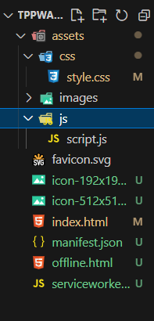

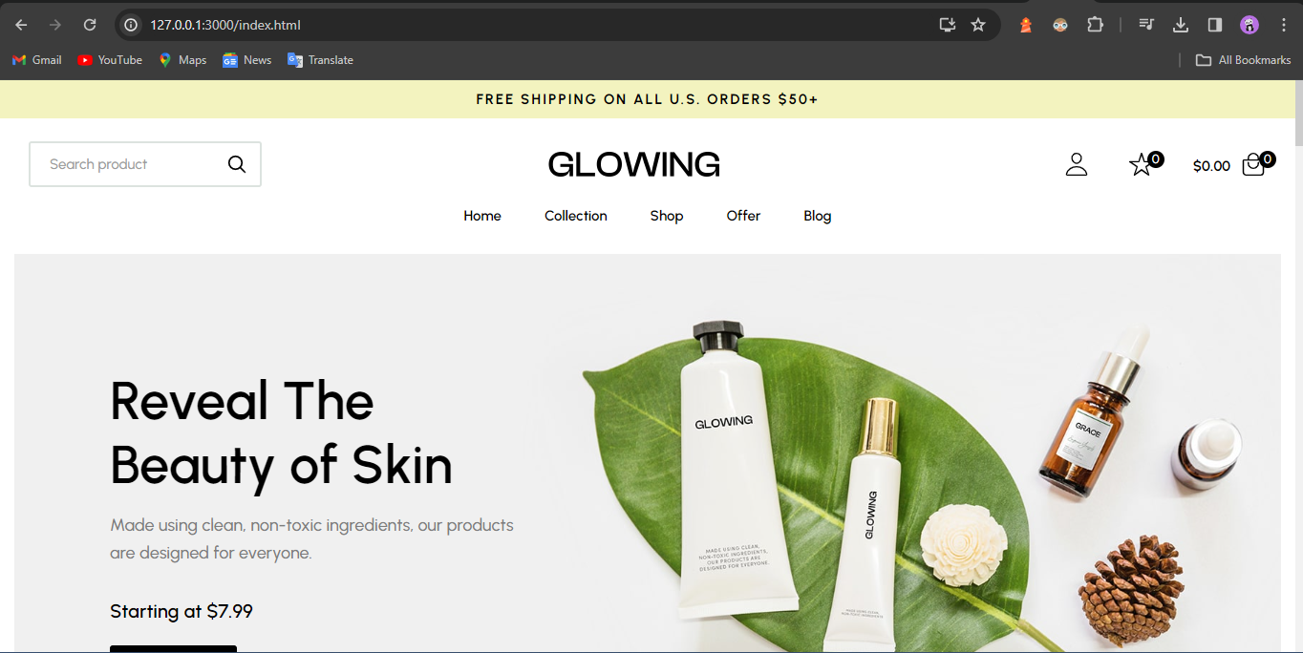

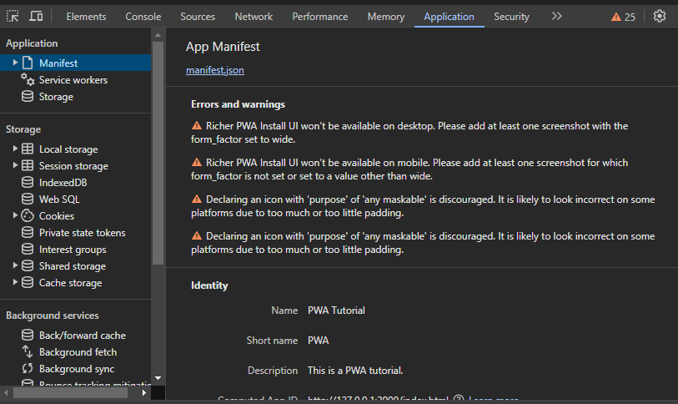

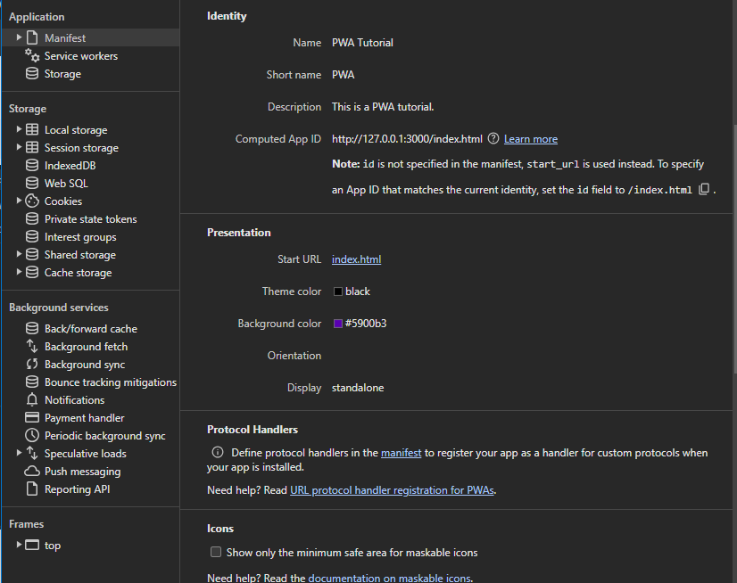

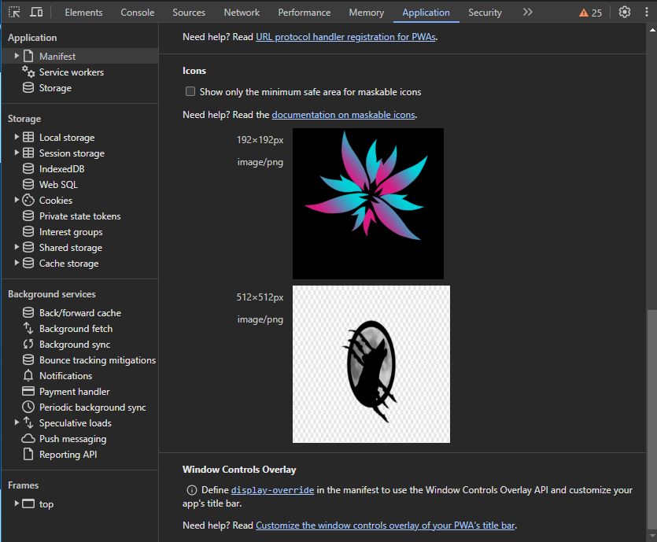

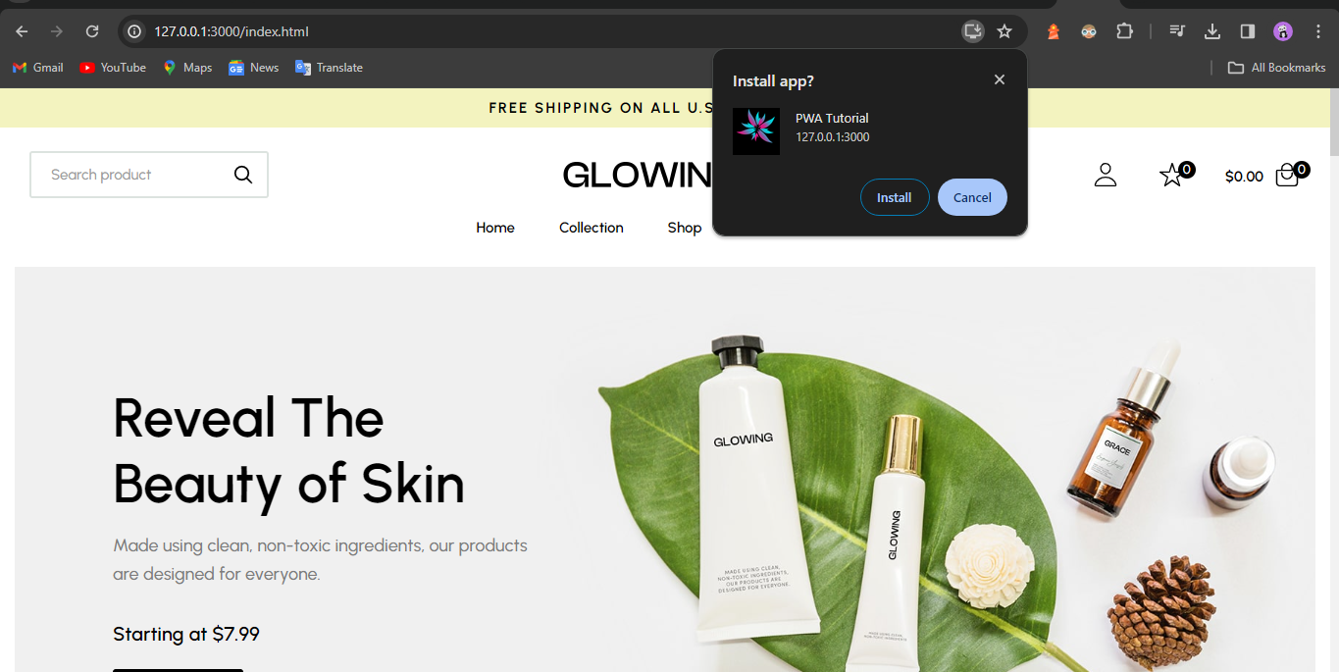

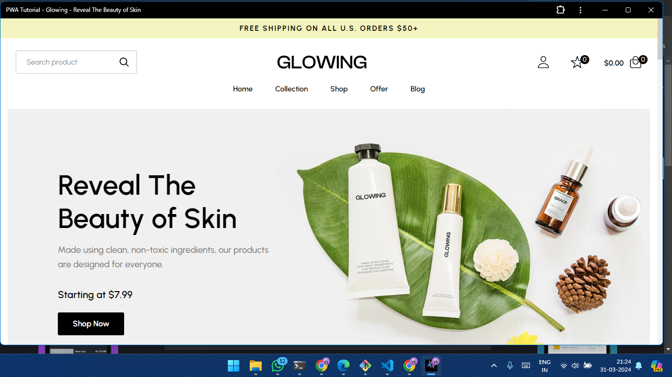

Conclusion -

In this experiment, we have successfully created a basic progressive web app of our web page and installed it in our desktop successfully.